1. Coupling
1.1. Content coupling
Related modules | Description | Improvement
Entity.order | There is some potentials that a class might call getDeliveryInfo() to change the deliveryInfo while this class knows nothing about the modifications from external. | Omit this get Delivery method. Make methods to modify Delivery Info if needed
1.2. Common coupling
Related modules | Description | Improvement
Entity.cart | This class contains the private static Cart cartInstance; | Instead of calling out directly this cartInstance of this cart class, we can pass this cart instance to the object we need.
1.3. Control coupling
Non
Related modules | Description | Improvement
1.4. Stamp coupling
Non
Related modules | Description | Improvement
1.5. Uncoupled
Non
Related modules | Description | Improvement
2. Cohesion
2.1. Coincidental cohesion
Non
Related modules | Description | Improvement
2.2. Logical cohesion
Related modules | Description | Improvement
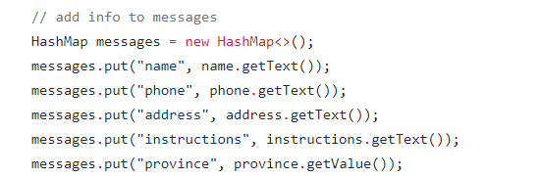  ShippingScreenHandler.java | All these do the same thing | Group into a function
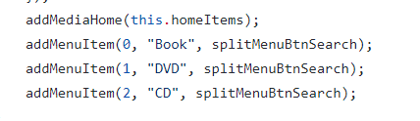  HomeScreenHandler.java | Similar task | Group into a function
2.3. Temporal cohesion
Related modules | Description | Improvement
2.4. Procedural cohesion
Related modules | Description | Improvement
2.5. Communicational cohesion
Related modules | Description | Improvement
2.6. Sequential cohesion
Related modules | Description | Improvement
2.7. Informational cohesion
Related modules | Description | Improvement
2.8. Functional cohesion
Related modules | Description | Improvement

